# 2018 Spring: COMP-SCI 5590/490 - Special Topics Mobile Programming

Lab Assignment 2

Deadline: 04/23/2018

### Overview

This assignment gives good practice on fetching data from APIs, parsing the results, handling errors, creating a customized list and other views and layouts

### Lab Assignment

**PART I:**

**Source Code**

<https://umkc.box.com/s/xlpoxnlaeagekcsbupd7dc63sfz7xq2e>

Go to the StepCounter folder in given source code and use it to complete PART I

**Step Counter App**

Create a mobile application with the following requirements.

1. The main activity should display a simple UI like this.

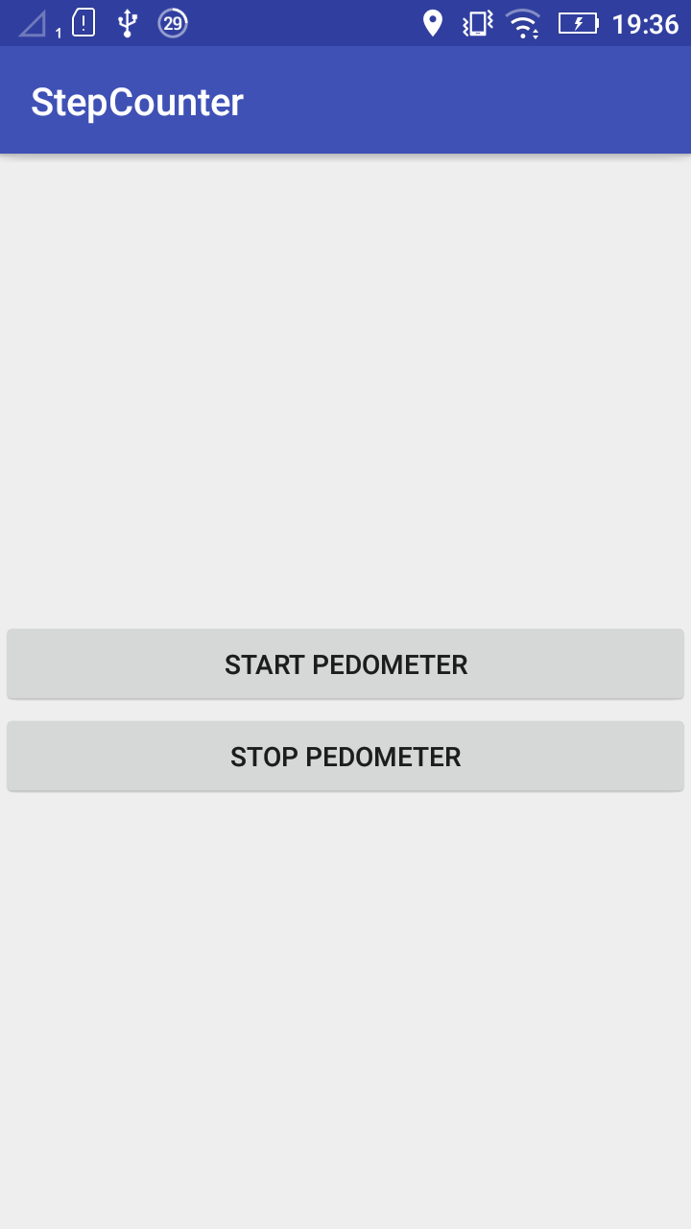

1. When a user clicks on start pedometer, moves around the app should count the steps. When the stop pedometer button is clicked the count should stop irrespective of motion.

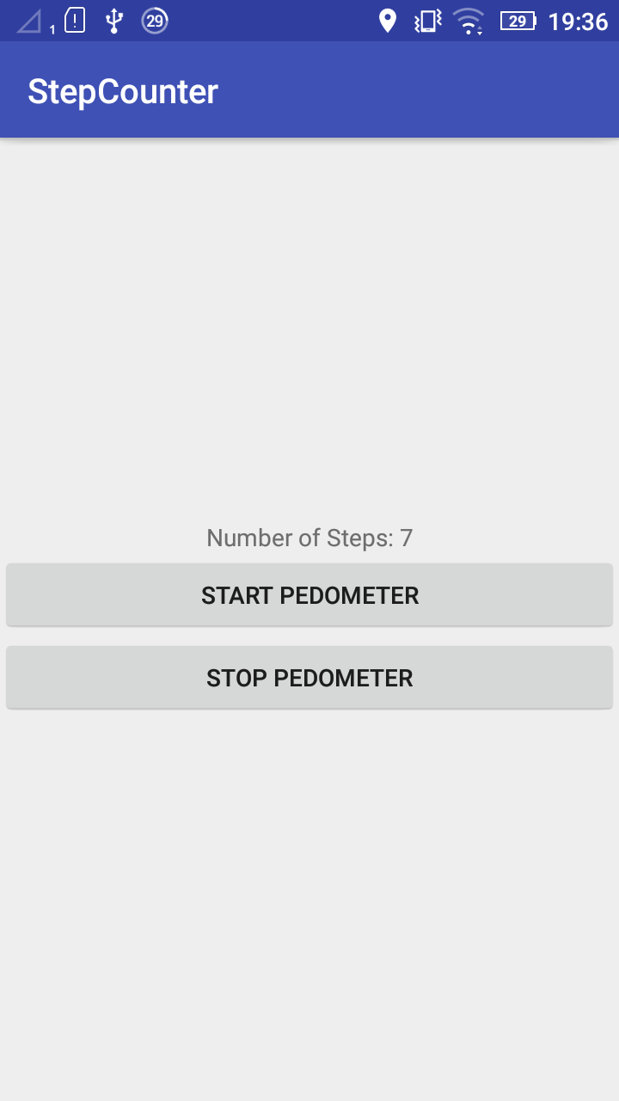

1. Create the activity_main.xml file such that it works as described above.
2. Follow the TODO instructions given in the MainActivity.java file

### PART II

Create a mobile application with the following requirements. The application should have good UI/UX.

1. Create an app that recognizes the facial features in a given picture and gives details about the status of their eyes and smile etc.[This](https://developers.google.com/vision/face-detection-concepts) will be a good place to start. Use your own image input.

Optional: Add face tracking feature that detects faces in a given video in your app.

1. Represent the results obtained in interesting views and layouts

**Submission Guidelines:**

1. Submit your source code and documentation to GitHub and represent the work through wiki page properly

2. Comment your code well.

3. Submit only a report of your work by defining the problem you attempted to solve and the end output along with the step by step explanation of your approach along with appropriate screenshots and code snippets at Turnitin in UMKC blackboard

4. Remember that similarity score should be less than 15 %

5. Submit the link to your wiki page along with other details in the following link

### <https://goo.gl/forms/cDmMhPECPYLAsSSh2>